**TITLE OF YOUR PAPER**

**Siti Rozakiyah Assurin Hassan1, Muhammad Nizar Amin2*, Fatema Rajab2, Kevin Cooke3, Susan Francester3**

1Mechanical Engineering Department, Seberang Perai Polytechnic, 13500 Permatang Pauh, Penang

2Faculty of Engineering Technology, Universiti Malaysia Perlis, 02100 Padang Besar, Perlis

3Miba Coating Group, Teer Coatings Corporation, 53100 Kuala Lumpur

*Corresponding author e-mail address: nizar@unimap.edu.my

**ABSTRACT**

The abstract should consist of a single paragraph containing no more than 200 words. Use Arial font 11pt, paragraph justified single spacing. It should be a summary of the paper and not an introduction. Because the abstract may be used in abstracting and indexing databases, it should be self-contained (i.e., no numerical references) and substantive in nature, presenting concisely the objectives, methodology used, results obtained, and their significance. A list of up to six keywords should immediately follow, with the keywords separated by commas and ending with a period. Use Arial font 11pt, paragraph justified single spacing.

**Keywords:** Mechanical, workshop, machine.

1. **Introduction**

Introduction as an inverted triangle: moving from very general to very specific. Establish the problem or issue you want to research: Highlight the importance of the problem/issue, and/or make general statements about the problem/issue, and/or Present an overview on current research on the issue or problem. Provide an overview of existing thinking about and/or research into your research problem. Identify a gap, problems or unresolved issues in the existing knowledge/research [1]. Identify a gap, problems or unresolved issues in the existing knowledge/research. Stress the value and importance/relevance of your research [2].

Figures are numbered in the order in which they are called out in the text. It is acceptable to embed figures in the manuscript. Caption is placed below the figure. Figure 1 for an example:

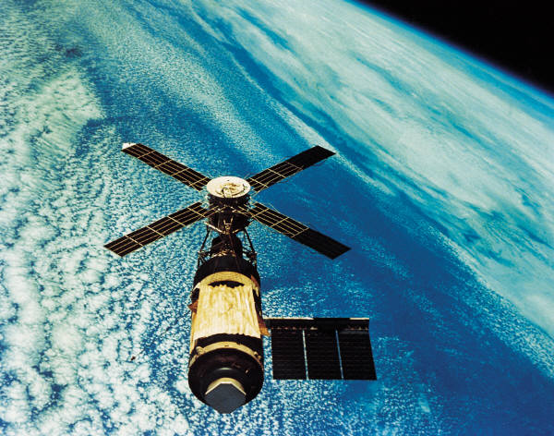

Fig. 1. Space shuttle

Tables are numbered in the order in which they referred to. They should appear in the document in numerical order and as close as possible to their first reference in the text. Table captions are handled identically to those for figures, except that they appear above the table, and when called out in the text, the word “Table” is always spelled out. Caption is placed on top of the table. See Table 1 for an example.

Table 1. Specification of machine

|  |  |  |
| --- | --- | --- |
| No. | Description | Specification |
| 1 | Name | Pepper Sorting Machine |
| 2 | Mechanism | Ejector, conveyor, colour sensor, vibrating feeder |
| 3 | Target Customer | MPB, Pepper Entrepreneur |
| 4 | Separating process | Colour Sensor, Air ejector |
| 5 | Material | Stainless steel for the structural frame, rubber conveyor belt |
| 6 | Safety | Hopper to protect roller, structural frame to guard the conveyor system |
| 7 | Sensor | Colour sensor programmed to detect pepper berries’ shade |
| 8 | Ejector | Compressed air ejector eject pepper berries which was scanned by the colour sensor |
| 9 | Cost | Approximately RM10 000 |

1. **Methodology**

The method section contains several sections such as participants, procedure, what happened in the study, measures/materials, what measures were used like surveys, what material - like special lab equipment, statistical analysis, which includes the fabrication process.

1. **Result and Discussion**

The purpose of a results section is to present the key results of your research/innovation without interpreting their meaning. Determine which results to present by deciding which are relevant to the question(s) or aims presented in the Introduction. The Results section does not need to include every result you obtained or observed. The results should be presented in an orderly sequence, using an outline as a guide for writing and following the sequence of the Methods section upon which the results are based. For every result there must be a method in the Methods section. It is important to carefully plan the tables and figures to ensure that their sequencing tells a story. If you are unsure whether to include certain results, go back to your research questions and decide whether the results are relevant to them. It doesn’t matter whether they are supportive or not, it’s about relevant.

The discussion section therefore needs to review your findings in the context of the literature and the existing knowledge about the subject. You also need to demonstrate that you understand the limitations of your research and the implications of your findings [3]. This section should be written in the present tense. If your results are controversial and/or unexpected, you should set them fully in context and explain why you think that you obtained them.

1. **Conclusion**

The conclusion is the very last part of your paper. Its main purposes are to clearly state the answer to the main research question, summarize and reflect on the project undertaken, make recommendations for future work on the topic and also show what new knowledge you have contributed. The conclusion should be concise and engaging. Aim to leave the reader with a clear understanding of the main discovery or argument that your research or innovation product has advanced. The writing format for references is to use the IEEE standard as shown below.

**References**

[1] W. Michaeli and G. Potsch, "Injection Molding: An Introduction" (Munchen: Hanser, Fachbuchverlag, 1995).

[2] D. Annicchiarico and J. R. Alcock, Mater. Manuf. Proces. 29, 662-682 (2014).

[3] Y. C. Lam, L. Y. Zhai, K. Tai and S. C. Fok, Int. J. Prod. Res. 42, 2047-2061 (2004).

[4] Aleena, M. (2018, November 4). Singing in the Amazon [Video file]. Retrieved from http://www.youtube.com/watch?v=Vxja83KLQXZs. (Accessed 11 Jan 2019).